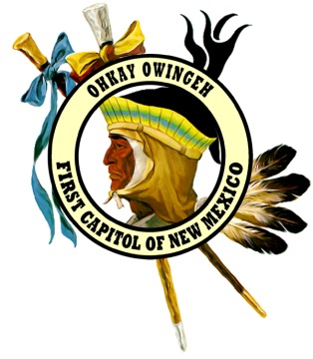
Tribal Data Resource / Tribal Enrollment
P.O. Box 1099~220 Popay Avenue
Ohkay Owingeh, NM 87566
Phone: 505-852-4400 Fax: 505-852-4820

ADDRESS UPDATE/REQUEST FORM

Please note: Plan accordingly as some requests may take 24 hours or more to fulfill.

Please Print All Information Legibly
____________________________ _________________________ __________________________
First Name Middle Name Last Name / Maiden Name if Married

DATE OF BIRTH: _____________________ PLACE OF BIRTH: _____________________________________
(City) (State)

SOCIAL SECURITY NO: _________________________________________________________
CURRENT MAILING ADDRESS: _________________________________________________________
_________________________________________________________
CURRENT PHYSICAL ADDRESS: _________________________________________________________ _________________________________________________________
PHONE/MESSAGE NO: (_______) ________________________________________________
PHONE TYPE: _______ MOBILE _______ HOME

MOTHER’S NAME: ________________________________________ PARENT ENROLLED? Y or N
FATHER’S NAME: _________________________________________ PARENT ENROLLED? Y or N

TYPE OF REQUEST: ______ADDRESS UPDATE ______TRIBAL ID CARD ($10 fee)
______NAME CHANGE (must provide proof)
______CIB-Certificate of Indian Blood-Paper Copy (free)
______Other: ____________________________________________________________

SIGNATURE: _____________________________________________ DATE: ______________________
********************************** FOR OFFICE USE ONLY************************************
DATE COMPLETED: ______________________________ ENROLLMENT NO: _________________
RETURNED/MAILED: _____________________________

