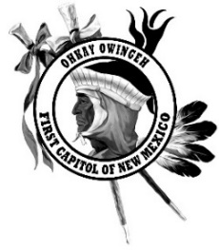
P.O. Box 1099
Ohkay Owingeh, NM 87566
Phone 505-852-4400 Fax 505-852-4820

2019 Ohkay Owingeh Feast Day Vendor Booths Information & Application

- Now accepting reservations for booth space beginning May 6, 2019. Reservations will also be conducted on June 23 and June 24, 2019. Spaces will be reserved on a first come first serve basis provided that full payment and application are received.
- Applications will need to be filled out by each vendor. Applications will be available at the Ohkay Owingeh Tribal Administration building.
- All food vendors must have proof of food handler’s certification for each person working in their booth as Indian Health Services will monitor food booths throughout the day.
- Food vendors must provide a minimum of two trash cans.
- Vendors must supply their own power needs.
- Each vendor is responsible for cleaning their area upon leaving or they will be cited into Tribal Courts for littering.
- Arts & Crafts vendors may bring their own set up i.e., canopy, tent, etc. provided it does not exceed 12x12 in size.
- Completed application and all fees will be accepted at the Ohkay Owingeh Tribal Administration building. Money orders, cashier’s checks or debit/credit cards only. Personal checks and cash will not be accepted so please plan accordingly. No donations or exchanges for merchandise will be allowed. Fees must be paid in full prior to set up. No exceptions.
- Vending will not be allowed in pueblo plaza or any other areas other than designated.
- Vendors must comply with all Ohkay Owingeh laws and regulations.
- All assigned spaces are final. Any disputes will be settled at the discretion of Tribal Officials.
- Ohkay Owingeh reserves the right to refuse vending space to any and all parties.

June 23 & 24, 2019 Vendor Fees
Booth Type | Fee Amount
Arts & Crafts - 8x8 (pre-set up)  Not to exceed 12x12 (self-set up) | $50 per day per booth
Food | $150 per day per booth
Novelty Items | $200 per day per booth
Snow Cones and/or Package Drinks only | $25 per day per booth
Prices may be higher to accommodate those with larger trailers or additional space accommodations.
Set-Up & Booth Assignment Times on June 23 & June 24
6:30 am

Office Use Only
Amt Paid
Cash, Check or MO #
Date Paid
Initials
Booth #
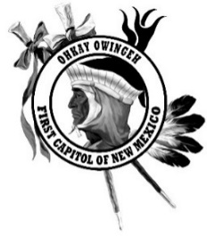

Ohkay Owingeh 2019 Feast Day Vendor Application

Vendor Information – Please write legibly
Name:
Phone Number:
Current mailing address:
City: |  | State: |  | ZIP Code:
E-Mail:

Type of Vendor
- Food Vendor
- Arts & Crafts (No food items, snow cones or drinks may be sold in this type of booth)
- Snow Cones & Package Drinks (No other items may be sold. Vendor will be charged extra)
*Please check the appropriate box(s)

Vendor Pricing
 | Booth Type |  | Fee Amount
 | Arts & Crafts |  | $50 per day per booth
 | Food |  | $150 per day per booth
 | Novelty Items |  | $200 per day per booth
 | Snow Cones & Packaged Drinks |  | $25 per day per booth
Do you want a pre-assembled booth? ________ Yes ________ No Pre-assembled booths are 8 x 8
*Prices for vendors may be higher to accommodate those with larger trailers or additional space

Release/Assurance
I hereby grant permission to Ohkay Owingeh, to use any photographs and/or audio/video recordings that may be made of me during the annual Ohkay Owingeh Feast Day for publicity and other promotional purposes. I will not hold Ohkay Owingeh responsible for any injuries, accidents, lost or stolen items or any hardships to me, my staff or my property while participating in the annual Ohkay Owingeh Feast Day on the grounds of Ohkay Owingeh.
My signature below indicates that I have read and agree to these conditions.
Signature |  |  | Date

Return to: ATTN: Ohkay Owingeh Annual Feast Day, P.O. Box 1099 Ohkay Owingeh, NM 87566
Money Orders made payable to Ohkay Owingeh

